STUDENT PERFORMANCE PREDICTION SYSTEM
PROJECT REPORT

Submitted by: Dhroov Havale
Department: Computer Science and Engineering (AI – ML)
College: Pimpri Chinchwad University
Project Guide: Mr. Moreshwar Mahale
Academic Year: 2026-2027

1. Abstract
The Student Performance Prediction System is a Python-based desktop application designed to manage student academic records and understand their performance. The system allows users to add, update, delete, and search student details. It calculates total marks, percentage, and grades automatically. It also provides charts and summaries to make it easier to compare performance across subjects. Student records are stored in a CSV file. The project uses Python and libraries such as CustomTkinter, pandas, Matplotlib, and scikit-learn. A Random Forest model is included to demonstrate machine learning. The current model is for learning purposes and should not be treated as a reliable prediction of future results without further training and testing.

2. Introduction
Student marks and attendance are important for understanding academic progress. Managing these details manually can take time and make it difficult to compare results. This project provides a simple application where student information can be stored and viewed in one place. It performs basic calculations automatically and presents information through charts and summaries.

3. Problem Statement
Maintaining student records manually can lead to repeated work, calculation mistakes, and difficulty in identifying subject-wise performance. A simple digital system is needed to organise student records, calculate results, and display useful performance information.

4. Objectives
- To create a simple desktop application for student record management.
- To add, edit, delete, and search student records.
- To calculate total marks, percentage, and grades automatically.
- To display subject averages and performance charts.
- To demonstrate the use of machine learning in an educational application.

5. Technologies Used
- Python: Main programming language used to build the application.
- CustomTkinter: Used to create the graphical user interface.
- CSV: Used to save student records in a simple file.
- pandas: Used for handling and analysing tabular data.
- Matplotlib: Used to create charts and graphs.
- scikit-learn: Used for the Random Forest machine-learning demonstration.
- IDLE: Can be used to edit and run the Python program.

6. System Requirements

6.1 Hardware Requirements
- Desktop or laptop computer
- Minimum 4 GB RAM recommended
- Sufficient storage for Python and project files

6.2 Software Requirements
- Windows, macOS, or Linux
- Python 3
- CustomTkinter, pandas, Matplotlib, and scikit-learn libraries
- IDLE or another Python editor

7. System Design and Working
The system has a graphical interface through which the user interacts with the application. When student details are entered, the program validates the input and calculates the results. The record is then stored in a CSV file. The analytics section reads the stored data and generates summaries and charts. The prediction section demonstrates how a machine-learning model can be connected to the application.

7.1 Main Modules
- Dashboard: Displays a summary of student records and performance.
- Student Management: Allows the user to add, edit, delete, and search student details.
- Result Calculation: Calculates total marks, percentage, and grade.
- Analytics: Displays subject averages and performance charts.
- Prediction: Demonstrates a machine-learning model using student data.
- CSV Storage: Saves records so they can be loaded when the application is opened again.

8. Subjects Included
The application records marks for the following five subjects:
- Data Structures and Algorithm
- Python Programming
- Digital and Logic Microprocessors
- Computer Organisation and Architecture
- Discrete Structures

9. Result Calculation
Each subject is considered to have a maximum of 100 marks. Therefore, the maximum total for five subjects is 500.
Total Marks = Sum of marks in all five subjects
Percentage = (Total Marks / 500) × 100
The grade boundaries used in this project are:
- A+: 90% and above
- A: 80% to below 90%
- B: 70% to below 80%
- C: 60% to below 70%
- D: 40% to below 60%
- F: Below 40%
Example: If a student scores 70 marks in each subject, the total is 350 out of 500. The percentage is 70%, and the grade is B according to the project's grading rules.

10. Implementation
The application is developed in Python. CustomTkinter is used for the interface, while program functions handle student records and calculations. The CSV file stores the data between sessions. pandas helps analyse the records, and Matplotlib displays charts. The scikit-learn Random Forest model is included to demonstrate a basic machine-learning workflow.
Important note: if the model estimates an average using the same subject marks that were used to calculate that average, it is not truly predicting a future result. A reliable future prediction would require suitable historical data and testing against separate future outcomes.

11. Testing
The following checks can be performed to confirm that the application works correctly:
- Open the application and check that the dashboard appears.

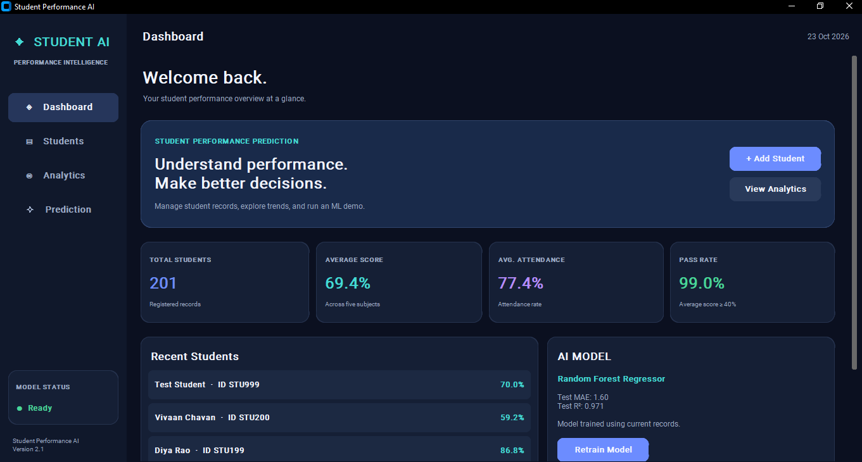

- Add a valid student record and confirm that it is saved.

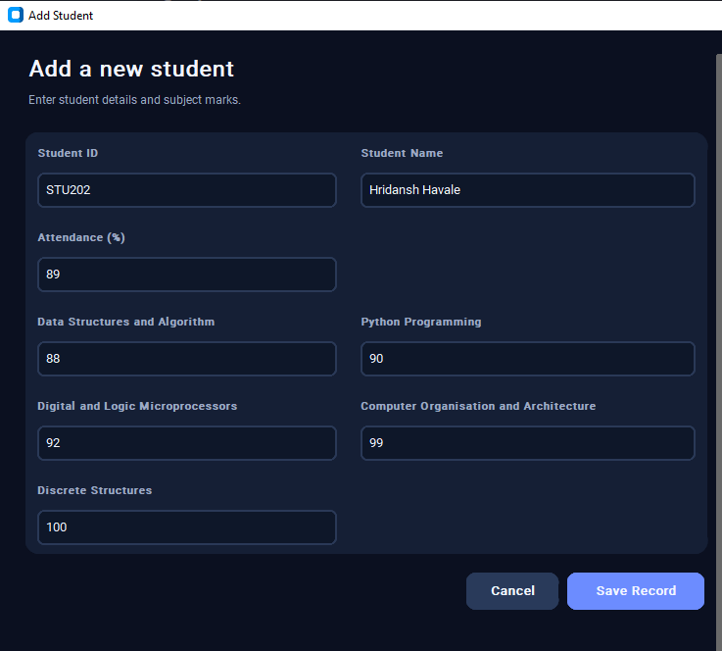

- Search for a student using their ID.

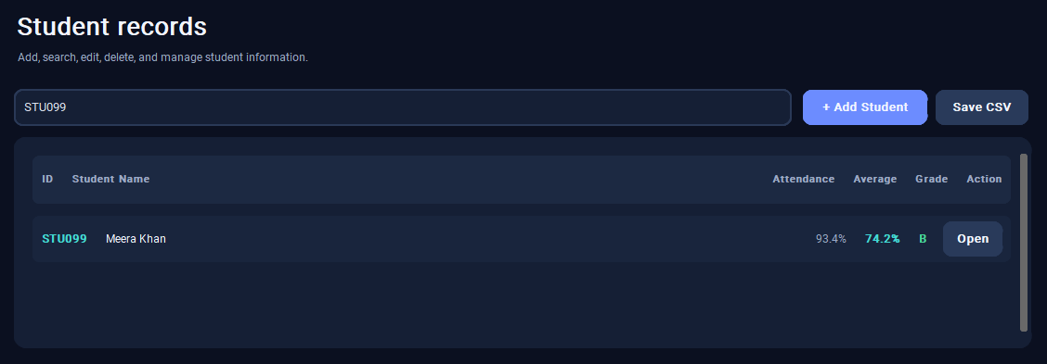

- Edit a record and verify that the changes are saved.

BEFORE: -
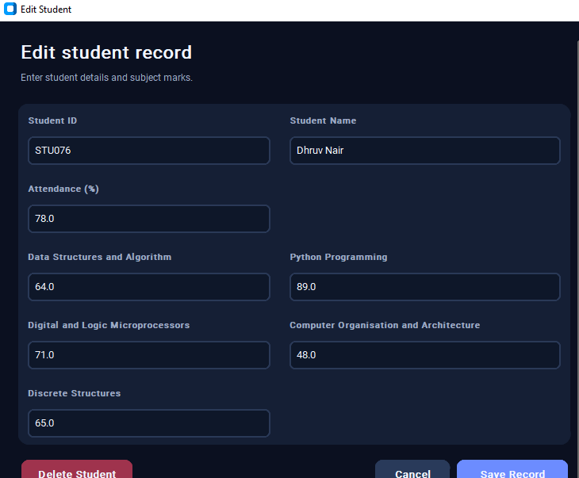

AFTER: -

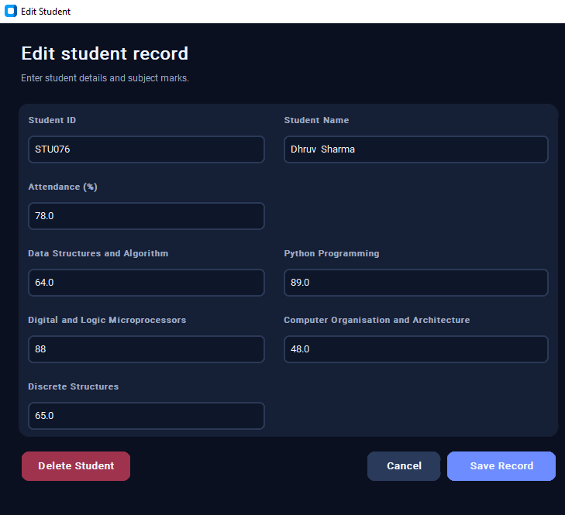

- Delete a record and confirm that it is removed.

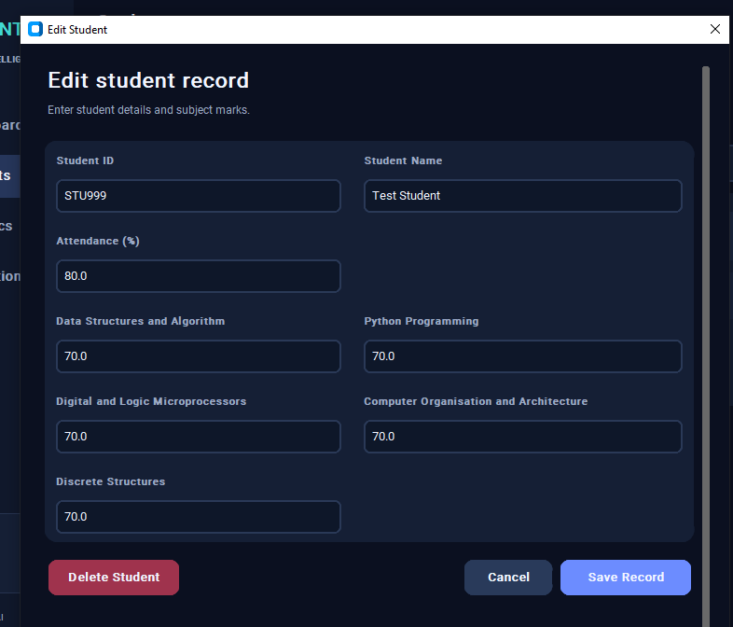

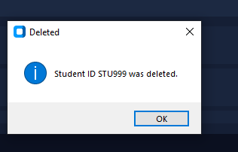

- Enter invalid marks and check that the application rejects them.

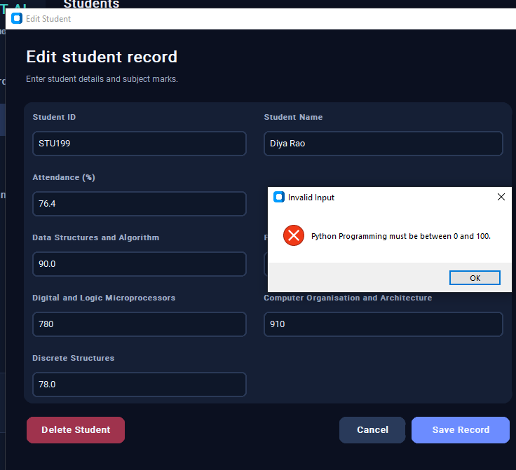

- Open analytics and verify that charts are displayed.

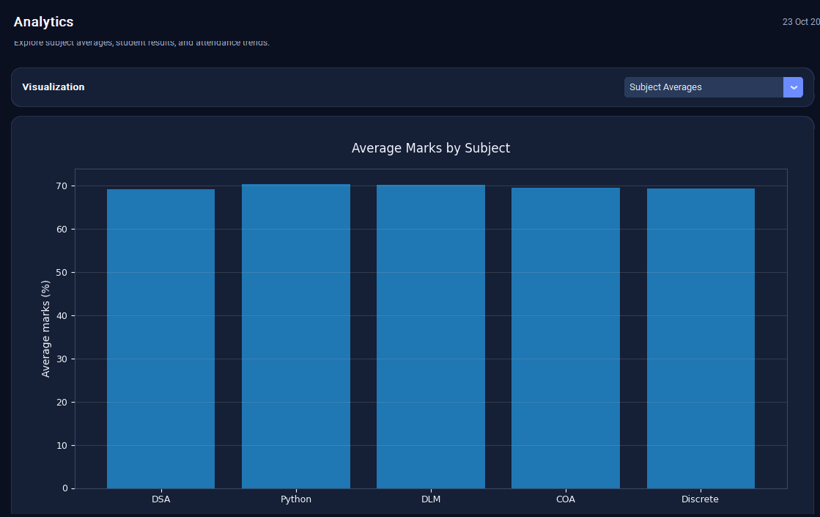

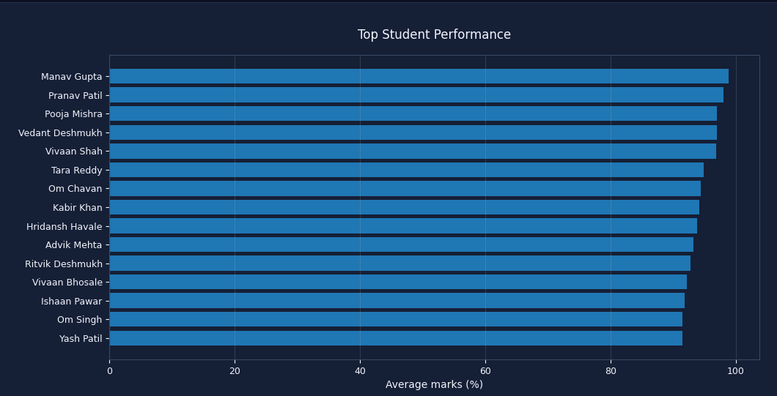

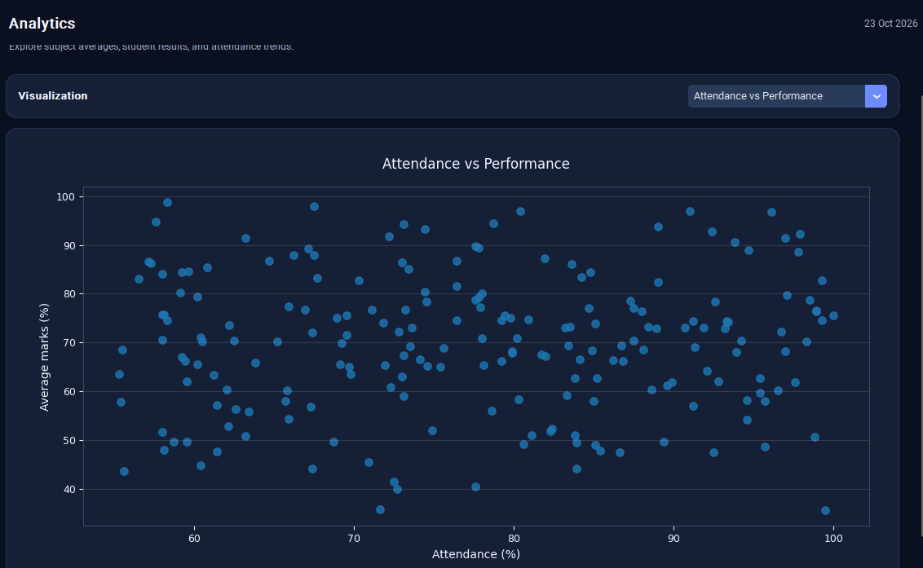

- Close and reopen the application to confirm that saved records remain available

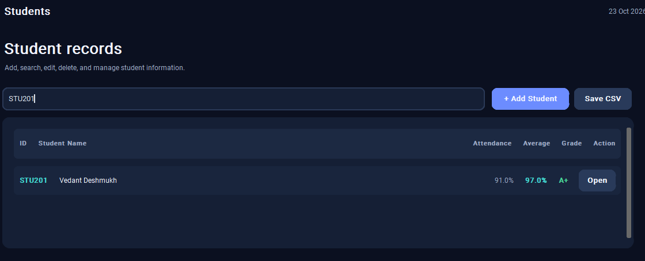

- Predictions and Machine Learning

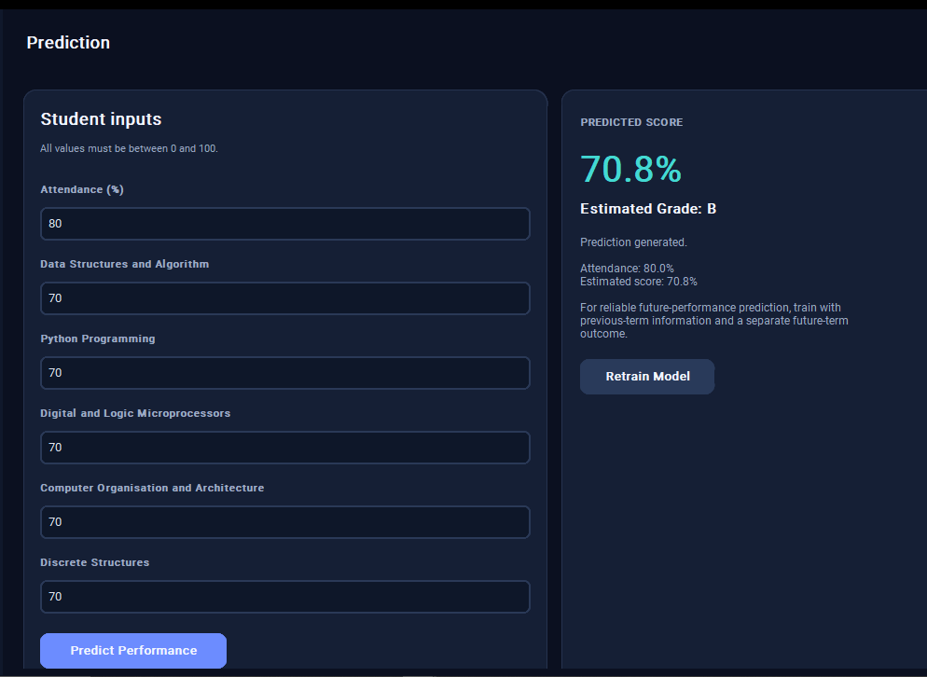

12. Advantages
- Reduces manual calculation of totals and percentages.
- Keeps student records organised in one place.
- Makes it easier to search and update records.
- Provides charts to compare subject performance.
- Offers practical experience with Python, data analysis, and machine learning.

13. Future Scope
- Use a database such as SQLite or PostgreSQL instead of a CSV file.
- Add login accounts and access permissions.
- Generate downloadable student reports.
- Include more academic terms and historical performance data.
- Train and test a proper prediction model using past results to estimate future outcomes.

14. Conclusion
The Student Performance Prediction System is a simple desktop application that helps manage student academic records and analyse performance. It automates result calculations, supports student record management, and presents data through charts. The project demonstrates the practical use of Python, data handling, visualisation, and introductory machine learning. With a database and a properly evaluated model, the system could be improved for broader academic use.

14. GitHub Repositories Link

Dhroov Havale - dhroovhavale-ocean/STUDENT-PERFORMANCE-PREDICTION-SYSTEM: Python Mini Project

Chetan Bulbule - nov4ra/Student-performance-prediction-system: python mini project

